**OOP Lab #9**

**Windows Form Application in C#**

**Windows Form:**

A Windows form is a Graphical User Interface framework for building Windows desktop apps. It provides one of the most productive ways to create desktop apps based on the visual designer provided in visual studio. Functionality such as drag and drop placement of visual controls makes it easy to build desktop apps.

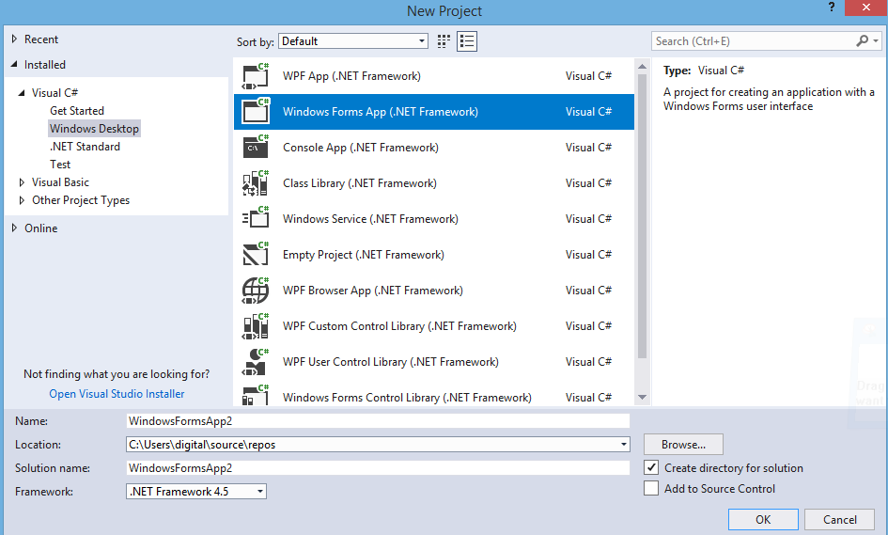

First of all we open visual studio and select windows form and give a name and click ok.

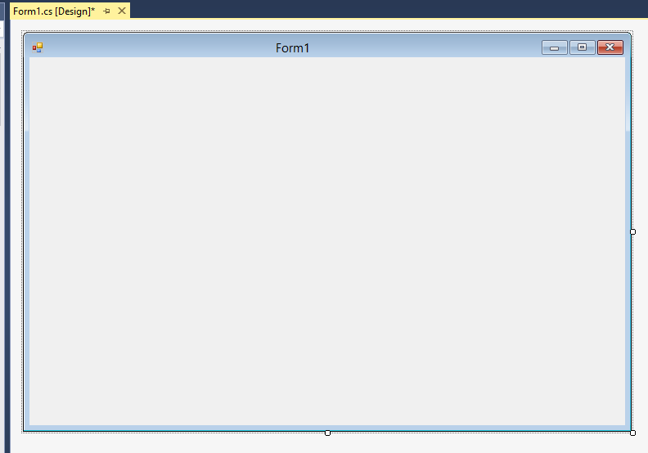This type of window will appear we will drag and drop our desire label, textbox, radio button and many more on it.

**First step is setting up the Form:**

**Appearance**

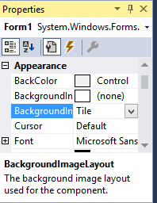

In this property we can change background color background image and background image layout.

**Font**

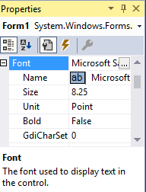

In this property we can change font size color style and make text italic and bold.

**Size:**

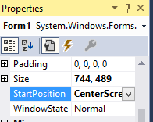

In this property we can control the our running form position center left right etc.

**Tool box:**

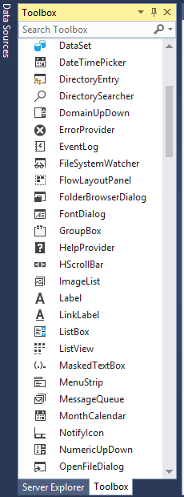

**By clicking on tool box we can choose our tools and drag and drop on a form.**

**This is my first calculator app in winform.**

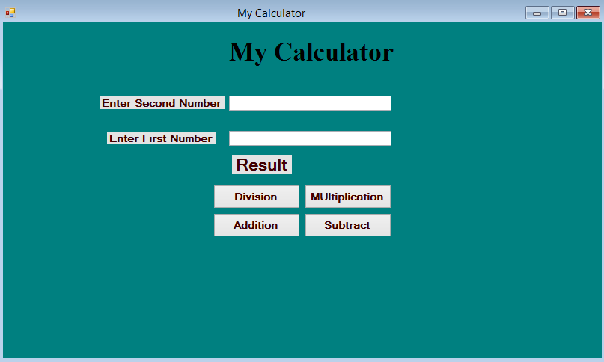

**Coding behind this app:**

namespace calculatorwindowform

{

public partial class Form1 : Form

{// this is my first WinForm App // Zohaib Amjad

public Form1()

{

InitializeComponent();

}

private void label1_Click(object sender, EventArgs e)

{

}

private void button4_Click(object sender, EventArgs e)

{

if (textBox1.Text !="" && textBox2.Text!="")

{

double num1 = double.Parse(textBox1.Text);

double num2 = double.Parse(textBox2.Text);

double result = num1 / num2;

label5.Text = " / Result is:" + result.ToString();

label5.Visible = true;

}

else

{

MessageBox.Show("Please Fill Both Fields......!!!!!");

}

}

private void Addition_Click(object sender, EventArgs e)

{

if (textBox1.Text !="" && textBox2.Text !="")

{

int num1 = int.Parse(textBox1.Text);

int num2 = int.Parse(textBox2.Text);

int result = num1 + num2;

label5.Text = " + Result is:" + result.ToString();

label5.Visible = true;

}

else

{

MessageBox.Show("Please Fill Both Fields......!!!!!");

}

}

private void Subtract_Click(object sender, EventArgs e)

{

if (textBox1.Text != "" && textBox2.Text != "")

{

int num1 = int.Parse(textBox1.Text);

int num2 = int.Parse(textBox2.Text);

int result = num1 - num2;

label5.Text = " - Result is:" + result.ToString();

label5.Visible = true;

}

else

{

MessageBox.Show("Please Fill Both Fields......!!!!!");

}

}

private void Multiplication_Click(object sender, EventArgs e)

{

if (textBox1.Text != "" && textBox2.Text != "")

{

int num1 = int.Parse(textBox1.Text);

int num2 = int.Parse(textBox2.Text);

int result = num1 * num2;

label5.Text = " * Result is:" + result.ToString();

label5.Visible = true;

}

else

{

MessageBox.Show("Please Fill Both Fields......!!!!!");

}

}

}

}

**Division Output:**

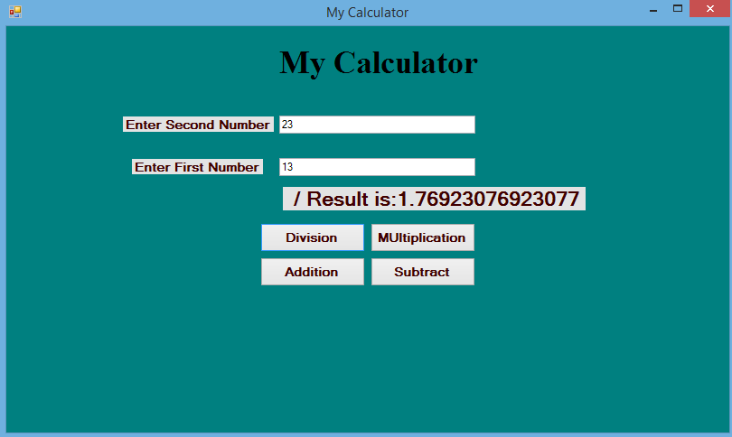

**Multiplication output:**

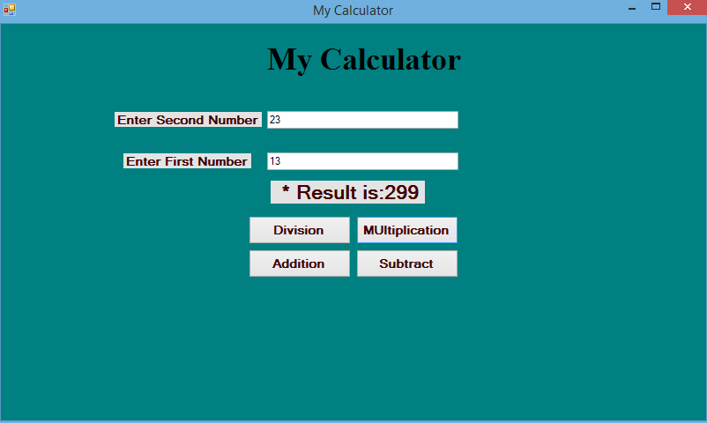

**Addition Output:**

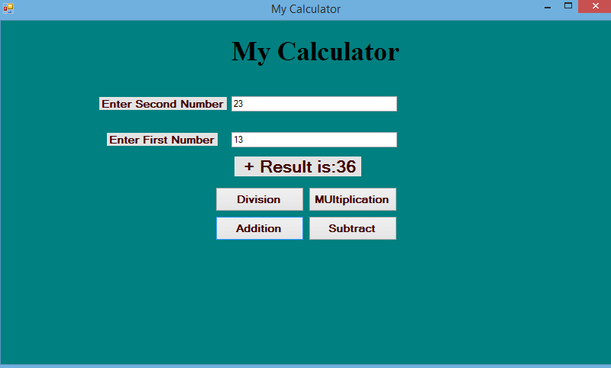

**Subtraction Output:**

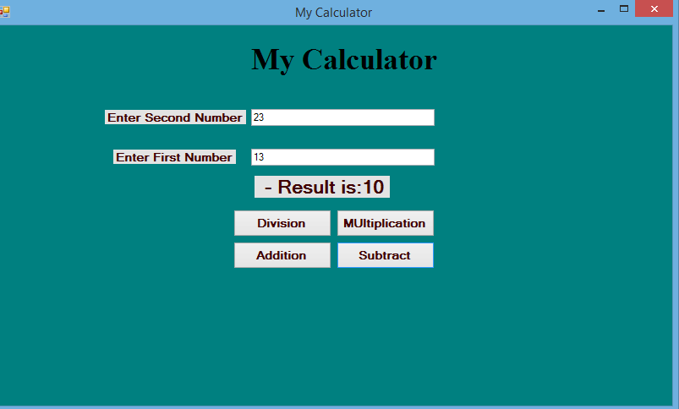

**When we textbox has empty and we click any button the output will show.**

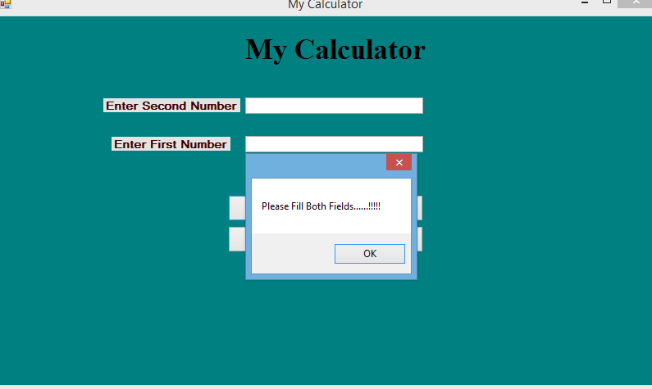

**My second winform:**

